Compressed Air: Centrifugal Calculations

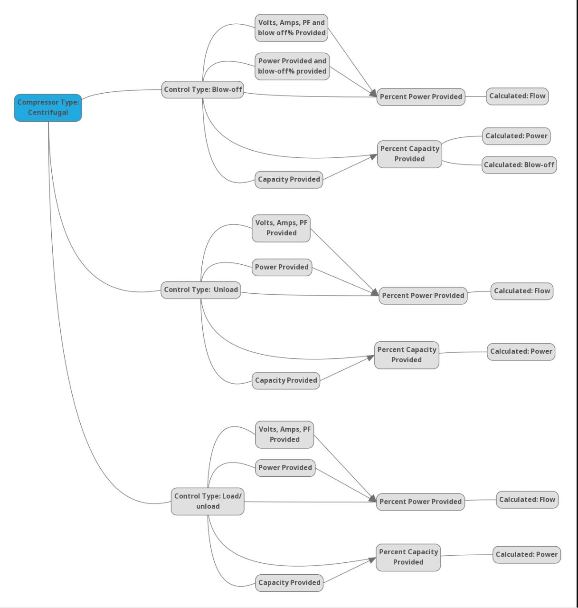
Control Type: Modulation w/Unload

Figure 1: Mindmap of Process

Variables/Inputs
Field Name | Name in Math | Units | Imperial Units | Metric Units
Compressor Rated capacity (aka full load) | C_fl | acfm | acfm
Power at Full Load Operating Pressure | kW_fl | kW |  | kW
Power calculated | kW_calc | kW |  | kW
Percent of Full Load Power | PerkW | % (fraction) | - | -
Percent Power at Full Load | kWPer_fl | % (fraction) | - | -
Percent Power at No Load | kWPer_nl | % (fraction) | - | -
Percent Capacity at Full Load | CPer_fl | % (fraction) | - | -
Percent Capacity at No Load | CPer_nl | % (fraction) | - | -
Percent of Capacity | CPer | % (fraction) | - | -
Percent Max Capacity at unload | CPer_ulB | acfm | acfm
Measured Capacity | C_measured | acfm | acfm
Surge (blowoff point) Flow | C_blow | acfm | acfm
Power at (surge) blowoff point | kW_blow | kW |  | kW
Percent capacity at blowoff | CPer_blow | % (fraction) | - | -
Percent Power at blowoff | kWPer_blow | % (fraction) | - | -
Percent Power at unload | kWPer_ul | % (fraction) | - | -
Percent Capacity at unload | CPer_ul | % (fraction) | - | -
Power at Max full flow (not full load) | kW_max | kW
Capacity at Max full flow (not full load) | C_max | acfm | acfm
Percent Power at Max full flow (not full load) | kWPer_max | % (fraction) | - | -
Percent Capacity at Max full flow (not full load) | CPer_max | % (fraction) | - | -
Surge airflow @ design conditions | C_blow | acfm | acfm
Max Full load (surge) pressure | P_max_surge | psig | psig
Capacity @max full load pressure | C_max_psi | acfm | acfm
Min Full Load (stonewall) pressure | P_min | psig | psig
Capacity @ min full load pressure | C_min_psi | acfm | acfm
Measured Amps | I_measured | amps | - | -
Power Factor | PF | % (fraction) | - | -
Measured Voltage | V_measured | V | - | -

Field Validation
Field Name | Name in Math | Min | Max | Y/R
Compressor Rated capacity (aka full load) | C_fl | 0 | N/A | -
Power at Full Load Operating Pressure | kW_fl | 0 | N/A | -
Power calculated | kW_calc | 0 | kW_calc =< kW_fl | R
Percent of Full Load Power | PerkW | 0 | 100 | R
Percent Power at Full Load | kWPer_fl | 0 | 100 | R
Percent Power at No Load | kWPer_nl | 0 | kWPer_nl <100 | R
Percent Capacity at Full Load | CPer_fl | 0 | 100 | R
Percent Capacity at No Load | CPer_nl | 0 | 100 | R
Percent of Measured Capacity | CPer | 0 | 100 | R
Percent Max Capacity at unload | CPer_ulB | 0 | CPer_ul< CPer_ulB<CPer_max | R
Measured Capacity | C_measured | 0 | C_measured =< C_fl | R
Surge (blowoff point) Flow | C_blow | 0 | C_blow =< C_fl | R
Power at (surge) blowoff point | kW_blow | 0 | 100 | R
Percent capacity at blowoff | CPer_blow | 0 | 100 | R
Percent Power at blowoff | kWPer_blow | 0 | 100 | R
Percent Power at unload | kWPer_ul | 0 | 100 | R
Percent Capacity at unload | CPer_ul | 0 | 100 | R
Power at Max full flow (not full load) | kW_max | 0 | 100 | R
Capacity at Max full flow (not full load) | C_max | 0 | C_max =< C_fl | R
Percent Power at Max full flow (not full load) | kWPer_max | 0 | 100 | R
Percent Capacity at Max full flow (not full load) | CPer_max | 0 | 100 | R
Surge airflow @ design conditions | C_blow | 0 | C_blow =< C_fl | R
Max Full load (surge) pressure | P_max_surge | 0 | P_max_surge > P_min | R
Capacity @max full load pressure | C_max_psi | 0 | C_max_psi =< C_fl | R
Min Full Load (stonewall) pressure | P_min | 0 | 100 | R
Capacity @ min full load pressure | C_min_psi | 0 | N/A | -
Measured Amps | I_measured | 0 | N/A | -
Power Factor | PF | 0 | 100 | R
Measured Voltage | V_measured | 0 | N/A | -

Math

Changing Discharge Pressure
When the discharge pressures change the acfm ratings will also change. The user will provide (or default that can be changed) three points. An equation will need to be created based on these three points. See pump/fan curves in measur for calculation “CurveFitVal”.
https://github.com/ORNL-AMO/AMO-Tools-Suite/blob/develop/src/calculator/util/CurveFitVal.cpp
Three points:
(C_min_psi , P_min) , (C_max_psi , P_max_surge) , (C_fl , P_fl)
Below are the values that can be changed using the derived equation. The user can change the pressure and the capacity will need to update accordingly.
Discharge Pressure  (Input) | Airflow  (Output)
P_fl | C_fl
P_max | C_max

Transform User Profile Input:
The user will have to provide a “usage profile.” The usage profile will require data for each hour in a 24-hour period. The user will choose one of five input options. The mindmap at the beginning will show what inputs will have to be transformed. Please not only controls with blow-off will require blowPer as an input and C_blow as an output. The provided data:

User Inputs | How to Transform | Follow Algorithm for
C_measured | PerC = C_measured/ C_fl | PerkW
V_measured, I_measured, PF, (and blowPer) | kW_measured = V_measured * I_measured * PF * 1.732 / 1000  PerkW = kW_measured / kW_fl | PerC
kW_measured (and blowPer) | PerkW = kW_measured / kW_fl | PerC
PerC | Continue to algorithm | PerkW
PerkW (and blowPer) | Continue to algorithm | PerC

Profile analysis:
General Equations used regardless of control type, needed for following calculations:
kWPer_nl = kW_nl / kW_fl
CPer_nl = C_nl / C_fl
kWPer_blow = kW_blow / kW_fl
CPer_blow = C_blow / C_fl
kWPer_max = kW_max / kW_fl
CPer_max = C_max / C_fl
CPer_ul = C_ul / C_fl
CPer_ulB = C_ul / C_max

Example:
Inputs |  | Outputs
Variable | Value | Variable | Value
kW_nl | 71.3 | kWPer_nl | .16
kW_fl | 452.3 | CPer_nl | 0
C_nl | 0 | kWPer_blow | .82
C_fl | 3138 | CPer_blow | .80
kW_blow | 370.9 | CPer_max | .96
C_blow | 2510 | kWPer_max | 1
kW_max | 452.3
C_max | 3011

Control Type: Load/unload
Using Percent Capacity as Input:
PerkW = ((1 - kWPer_nl) / (CPer_fl-CPer_nl))*(CPer) + kWPer_nl
kW_calc = PerkW * kW_fl
C_calc = C_fl * CPer
Example:
Inputs |  | Outputs
Variable | Value | Variable | Value
kWPer_nl | .16 | PerkW | .360
CPer_fl | 1 | kW_calc | 162.7
CPer_nl | 0 | C_calc | 753
CPer | .24

Using Percent Power as Input:
CPer = (PerkW - kWPer_nl) * ((CPer_fl-CPer_nl) / (1 - kWPer_nl))
C_calc = C_fl * CPer
kW_calc = PerkW * kW_fl
Example:
Inputs |  | Outputs
Variable | Value | Variable | Value
kWPer_nl | .16 | CPer | .24
CPer_fl | 1 | kW_calc | 162.7
CPer_nl | 0 | C_calc | 753
PerkW | .36

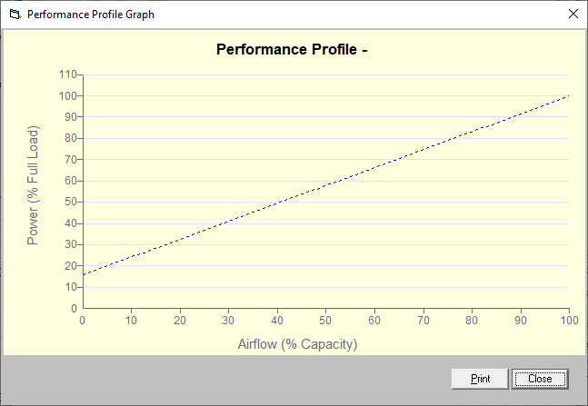
Figure 2: Performance Profile for Load/unload control type

Control Type: Inlet Butterfly with Blowoff or Inlet Guide Vane with Blowoff
Using Percent Capacity as Input:
IF
CPer < CPer_blow
Then
PerkW = kWPer_blow
blowPer = CPer_blow - CPer
Else
PerkW = ((1- kWPer_blow)/(1- CPer_blow))*( CPer)+1 -((1 - kWPer_blow)/( 1 - CPer_blow))*1)

kW_calc = PerkW * kW_fl
C_calc = C_fl * CPer
C_blow = blowPer * C_fl

Example:
Inputs |  | Outputs
Variable | Value | Variable | Value
CPer | .94 | PerkW | .946
CPer_blow | .80 | kW_calc | 427.9
kWPer_blow | .82 | C_calc | 2950
kW_fl | 452.3 | C_blow | 0
C_fl | 3138

Using Percent Power and blowoffPer as Input:
IF
PerkW <=kWPer_blow
Then
CPer = CPer_blow- blowPer
Else
CPer = ((1-CPer_blow)/(1-kWPer_blow))*( PerkW -1+((1kWPer_blow)/(1-CPer_blow)))

C_calc = C_fl * CPer
kW_calc = PerkW * kW_fl
C_blow = blowPer * C_fl

Example:
Inputs |  | Outputs
Variable | Value | Variable | Value
PerkW | .82 | CPer | .12
CPer_blow | .80 | kW_calc | 370.9
kWPer_blow | .82 | C_calc | 377
kW_fl | 452.3 | C_blow | 2133
C_fl | 3138
blowPer | .6798

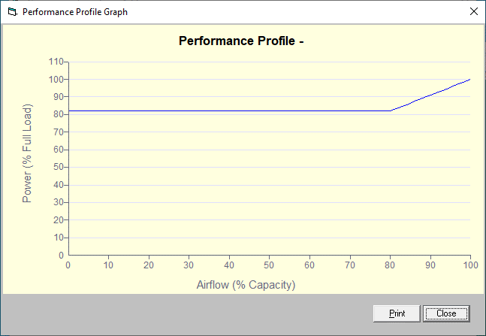
Figure 3: Performance Profile for Blowoff Control Type

Control Type: Inlet Guide Vane Modulation with Unloading or Butterfly Modulation with unloading
Using Percent Capacity as Input:
IF
CPer <kWPer_ul
Then
PerkW = ((kWPer_ul - kWPer_nl)/( CPer_ul - CPer_nl))*( CPer)+ kWPer_nl
Else IF
CPer < CPer_max
Then
PerkW = ((kWPer_max - kWPer_ul)/( CPer_max - CPer_ul))*( CPer)+ kWPer_max -(( kWPer_max - kWPer_ul)/( CPer_max - CPer_ul))* CPer_max
Else
PerkW = 1

kW_calc = PerkW * kW_fl
C_calc = C_fl * CPer
Example:
Inputs |  | Outputs
Variable | Value | Variable | Value
CPer | .24 | PerkW | .367
kWPer_ul | .92 | kW_calc | 165.9
kWPer_nl | .16 | C_calc | 753
CPer_ul | .87
kWPer_max | 1
CPer_max | .96
kW_fl | 452.3
C_fl | 3138

Using Percent Power as Input:
IF
PerkW <=kWPer_nl
Then
CPer = CPer_nl
Else IF
PerkW < kWPer_ul
Then
CPer = (PerkW -kWPer_nl)*(( CPer_ul - CPer_nl)/( kWPer_ul -kWPer_nl))
Else IF
PerkW >= kWPer_ul
Then
CPer = ((1- CPer_ulB)/( kWPer_max - kWPer_ul))* PerkW +(1-(1 - CPer_ulB)/( kWPer_max - kWPer_ul))
Else
CPer = 1

IF
CPer < CPer_ulB
Then
C_calc = CPer * C_fl
Else
C_calc = CPer * C_max

kW_calc = PerkW * kW_fl

Example:
Inputs |  | Outputs
Variable | Value | Variable | Value
PerkW | .94 | CPer | .933
kWPer_ul | .92 | kW_calc | 425
kWPer_nl | .158 | C_calc | 2809
kWPer_max | 1
CPer_max | .96
kW_fl | 452.3
C_fl | 3138
CPer_ulB | .91
C_max | 2731
CPer_ul | .87

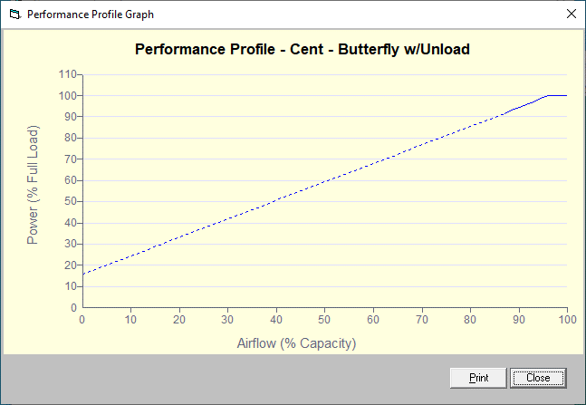
Figure 4: Performance Profile for Modulation with Unload

